Material availability assessment using system dynamics: The case of tellurium
Supplementary Information
Francis Hanna¹, Preeti Nain¹, Annick Anctil^{1*}
¹Department of Civil & Environmental Engineering, Michigan State University
*Corresponding author: anctilan@msu.edu
- System dynamics modeling
Table 1: Tellurium production from copper electrorefining – variables/assumptions for forecast calculations
Variable | Description | [Study Period]: Value | Notes and References
Forecast calculations
$$δ$$ | Te content in copper anodes (ppm) | [2023 - 2050]: 110 | This is the average reported tellurium content [43]
$$γ$$ | Te yield from anode slimes (%) | [2023, 2050]: [50 -  $γ_{ultimate}$] | Tellurium yield is assumed to be correlated with the Te Price, with a delay of 5 years [26, 44, 45].
$$γ_{ultimate}$$ | Maximum achievable tellurium yield from copper anode slimes (%) | [2023 - 2050]: 90 | Recovery efficiencies reported in literature and patents on anode slimes processing [47-49]
$$α$$ | Te loss in electrorefining process (%) | [2023 - 2050]: 2 | [44, 46]
C(t) | Future copper anodes production | 1.94% | Linear regression is conducted in R-Studio software [50] using historical data [51].
Delay | Increase in tellurium yield based on price (years) | 4 | Assumed based on historical trends. The two reported improvements in tellurium yield occur 4 years after two major material price increases in 2005 and 2008 respectively [6, 26, 44, 45].
Note: USGS database (United States Geological Survey) reports the annual copper anode production between 2000 and 2022 (C(t)) [51].

- Historical data analysis

  - Tellurium Demand
PV sector demand
Figure 3-a shows the historical CdTe production as per the data retrieved from the IEA reports [29]. Figure 3-b shows the film thickness and module efficiency used in the historical data analysis based on the data retrieved from First Solar annual reports and technical datasheets [24, 30-32]. The considered tellurium mass fraction in CdTe and the active layer film density are 0.53 and 5.9 mt/m³, respectively [12, 18]
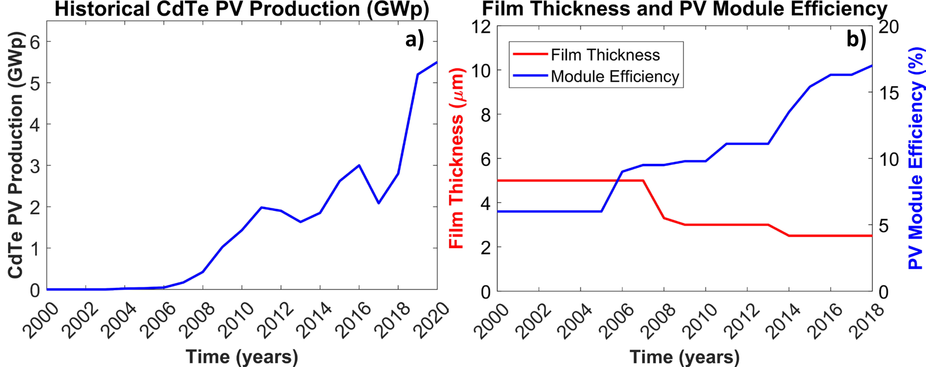
Figure 1: Tellurium PV-demand variables used in historical demand calculations. (a) Annual CdTe Production (data from [9]), (b) CdTe Film Thickness and Efficiency [24, 30-32]
Non-PV sector demand
The reported tellurium flows data (between 2000 and 2010) as per Kavlak and Graedel (2013) [37] for five principal use sectors (electronics, rubber, chemicals and catalysts, additives to non-ferrous alloys, and iron and steel products) is used in the present study. For 2011- 2022, data is compiled using the reported tellurium production in USGS and the respective material demand by each sector [6]. A detailed material flow analysis for each industry that uses tellurium is beyond the scope of this study.
  - Tellurium Supply
Copper Electrorefining
Historical tellurium supply from copper electrorefining is estimated using the below equation (Equation (4) in the manuscript)
${Te}_{Cu}\left(t\right)=C\left(t\right)×γ(t)×δ(t)×α(t)$
(1)
Where Te_{Cu}(t) is the tellurium production from copper electrorefining at year (t) (mt); C(t) is the copper anode production at year (t) (mt); γ(t) is the tellurium yield from anode slime processing at year (t) (%); δ(t) is the tellurium content in copper anodes at year (t) (ppm); α(t) is the tellurium loss in the electrorefining process at year (t) (%).
Table 2: Tellurium supply from copper electrorefining - Variables assumptions throughout the study period
Variable | Description | [Study Period]: Value | Notes and References
Historical calculations
$$δ$$ | Te content in copper anodes (ppm) | [2000 - 2002]: 110  [2003 - 2006]: 90  [2007 - 2009]: 100  [2010 - 2012]: 130  [2013 - 2015]: 110  [2016 - 2018]: 100  [2019 - 2022]: 120 | Retrieved from the latest global Refinery Tankhouse Survey [43]
$$γ$$ | Te yield from anode slimes (%) | [2000, 2007]: 33  [2008, 2010]: 45  [2011, 2018]: 50 | Tellurium yield is assumed to be correlated with the Te Price. If Te price increases, the yield increase after 5 years [26, 44, 45]
$$α$$ | Te loss in electrorefining process (%) | 2 | [44, 46]
Note: USGS database (United States Geological Survey) reports the annual copper anode production between 2000 and 2022 (C(t)) [51].

- Tellurium price
Tellurium price is assumed to vary primarily as a function of supply and demand. A cross-correlation analysis is conducted after compiling the data on historical tellurium price and supply surplus/gap. As shown in the figure below, tellurium price and supply surplus/gap negatively correlate with a lag of three years. This results in the highest Spearman correlation factor of 0.62. Following this analysis, a regression analysis is conducted for the adjusted dataset. The below first-order relationship is developed for tellurium price (p-value = 0.02602).
Te_{Price} = 291.662152 - 1.336251*Te_{Surplus\Gap}
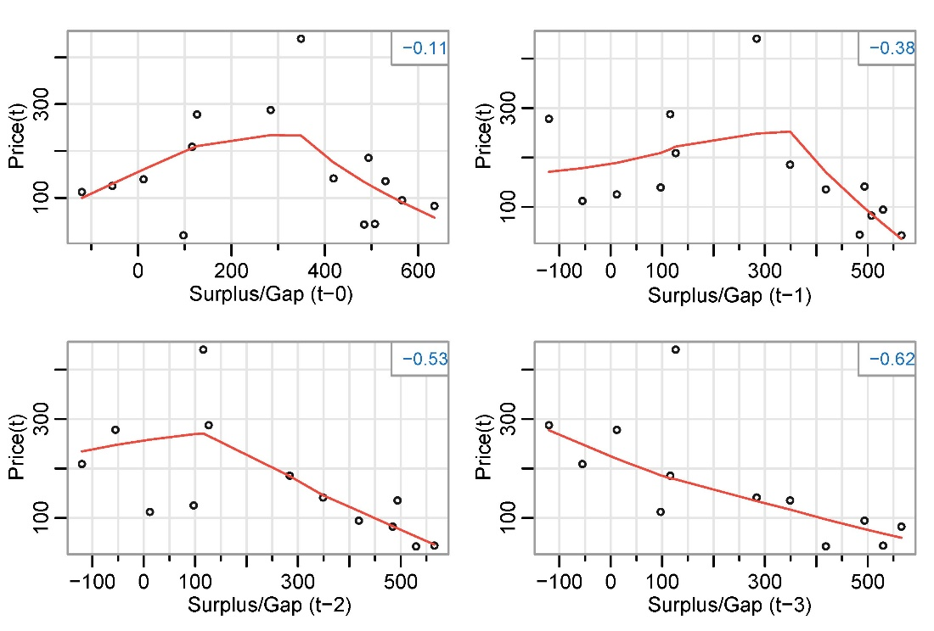
Figure 2: Cross-correlation analysis of historical tellurium price and surplus/gap

- Scenarios development
We use three sets of inputs in the developed system dynamics model. The inputs differ by the planned growth in CdTe PV, the forecasted film thickness, the forecasted module efficiency, and other supply and demand exogenous parameters. The table below summarizes the inputs for each scenario.
 | Low Demand Scenario | Business-as-Usual Scenario | High Demand Scenario
CdTe PV market share in 2050 (%) | 3.9% | 15% | 30%
Film thickness | 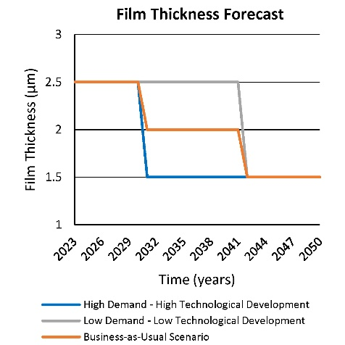  The low and high-demand scenarios involve slow and fast technological development. On the other hand, the business-as-usual scenario involves a steady improvement in film thickness.
Module efficiency | 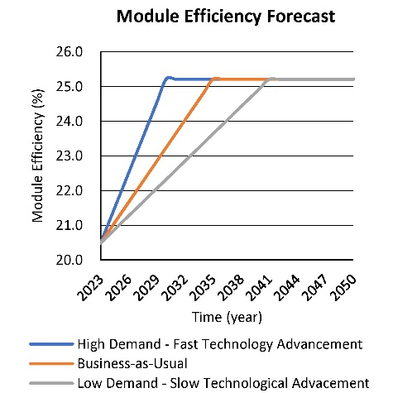  The module efficiency is retrieved between the years 2011 and 2020. Historical data shows a consistent trend, which is used to forecast the module efficiency in the business-as-usual scenario. Accordingly, early and late technology developments are assumed for the high- and low-demand scenarios, respectively.
Tellurium direct mining growth rate | Assumed to grow at the same rate as copper mining ~ 2.5%
Te yield improvement | The tellurium recovery from anode slimes is assumed to be improve as a function of the tellurium price. Tellurium recovery efficiency increases linearly with increasing tellurium price, with a maximum achievable tellurium recovery of 90%. The linear relationship is assumed based on previous trends of reported tellurium yield between years 2000 and 2020.
Figure 3: Technology development assumptions for low-demand, business-as-usual, and high-demand scenarios

System Dynamics Model Structure
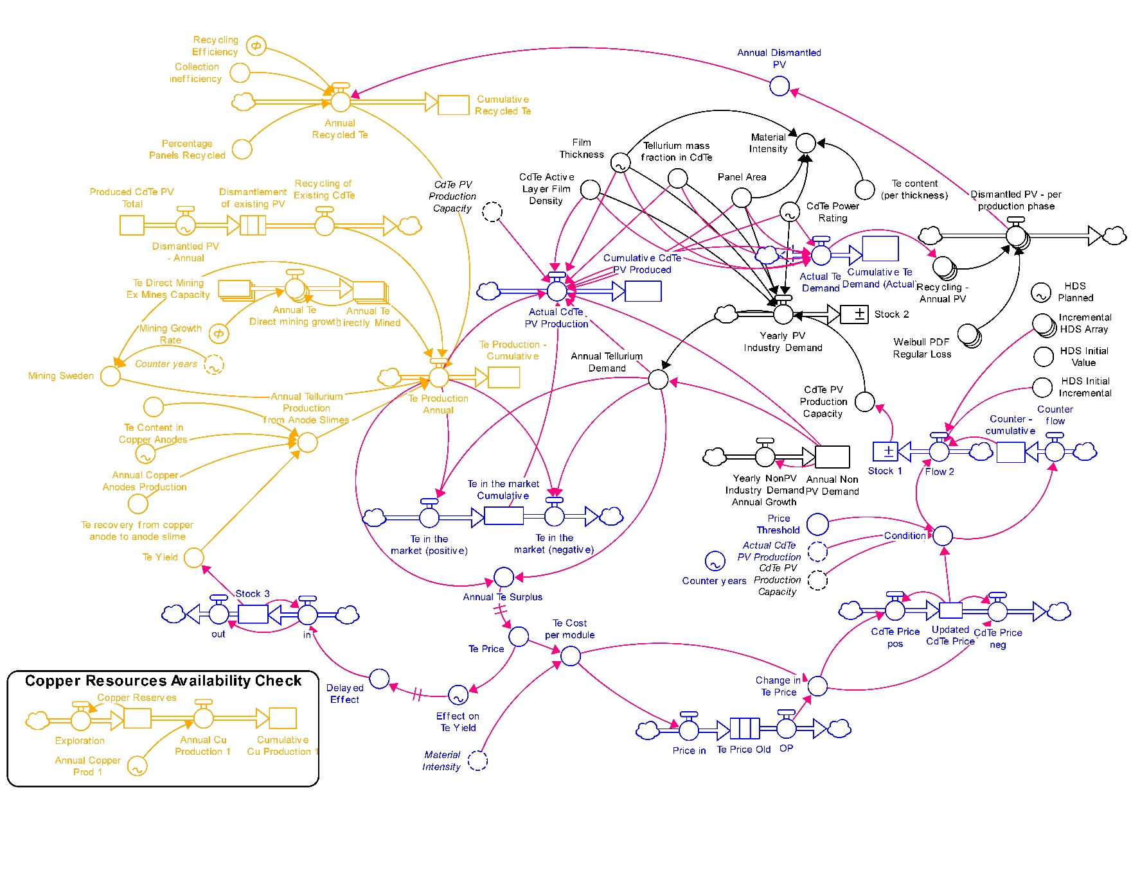
Figure 4: System dynamics model developed using Stella
System Dynamics Modelling Script
{ ARRAY DIMENSIONS }
Annual_Te_Direct_mining_growth[Existing_Mines]
Annual_Te_Directly_Mined[Existing_Mines]
"Dismantled_PV_-_per_production_phase"[Production_2023]
Incremental_HDS_Array[High_Development_Scenario]
"Recycling_-_Annual_PV"[Production_2023]
Te_Direct_Mining_Ex_Mines_Capacity[Existing_Mines]
Weibull_PDF_Regular_Loss[Production_2023]
{ SUBSCRIPT NAMES }
Existing_Mines = Dashuigou_in_China,Moctezuma_in_Mexico,Kaankberg_in_Sweden,Deer_Horne_in_Canada
High_Development_Scenario = Element_1,Element_2,Element_3,Element_4,Element_5,Element_6,Element_7,Element_8,Element_9,Element_10,Element_11,Element_12,Element_13,Element_14,Element_15,Element_16,Element_17,Element_18,Element_19,Element_20,Element_21,Element_22,Element_23,Element_24,Element_25,Element_26,Element_27,Element_28
Low_Development_Scenario = Element_1,Element_2,Element_3,Element_4,Element_5,Element_6,Element_7,Element_8,Element_9,Element_10,Element_11,Element_12,Element_13,Element_14,Element_15,Element_16,Element_17,Element_18,Element_19,Element_20,Element_21,Element_22,Element_23,Element_24,Element_25,Element_26,Element_27,Element_28
Medium_Development_Scenario = Element_1,Element_2,Element_3,Element_4,Element_5,Element_6,Element_7,Element_8,Element_9,Element_10,Element_11,Element_12,Element_13,Element_14,Element_15,Element_16,Element_17,Element_18,Element_19,Element_20,Element_21,Element_22,Element_23,Element_24,Element_25,Element_26,Element_27,Element_28
Production_2023 = Element_1,Element_2,Element_3,Element_4,Element_5,Element_6,Element_7,Element_8,Element_9,Element_10,Element_11,Element_12,Element_13,Element_14,Element_15,Element_16,Element_17,Element_18,Element_19,Element_20,Element_21,Element_22,Element_23,Element_24,Element_25,Element_26,Element_27,Element_28
{ INITIALIZATION EQUATIONS }
: s Produced_CdTe_PV_Total = 2418
: f "Dismantled_PV_-_Annual" = TIME
: c Collection_inefficiency = 0.9
: c Recycling_Efficiency = 90
: l Dismantlement_of_existing_PV = "Dismantled_PV_-_Annual"*Collection_inefficiency*Recycling_Efficiency/100
TRANSIT TIME = 1
FIFO
: c "Te_content_(per_thickness)" = 0.0081
: c Film_Thickness = TIME
: c Panel_Area = 2.52
: c CdTe_Power_Rating = TIME
: c Material_Intensity = "Te_content_(per_thickness)"*Film_Thickness*Panel_Area/CdTe_Power_Rating
: c Te_Price = DELAY(IF(Annual_Te_Surplus>180) THEN(50) ELSE( 291.662152 - 1.336251*Annual_Te_Surplus), 3, 70)
: c Te_Cost_per_module = Material_Intensity*Te_Price
: f Price_in = Te_Cost_per_module
: l Te_Price_Old = Price_in
TRANSIT TIME = 0
: s Annual_Non_PV_Demand = 348
: s Annual_Te_Directly_Mined[Dashuigou_in_China] = 12
: s Annual_Te_Directly_Mined[Moctezuma_in_Mexico] = 15
: s Annual_Te_Directly_Mined[Kaankberg_in_Sweden] = 85
: s Annual_Te_Directly_Mined[Deer_Horne_in_Canada] = 0
: s Copper_Reserves = 704000000
: s "Counter_-_cumulative" = 1
: s Cumulative_CdTe_PV_Produced = 0
: f Exploration = Copper_Reserves*CGROWTH(2)
: c Annual_Copper_Prod_1 = TIME
: f Annual_Cu_Production_1 = Annual_Copper_Prod_1
: s Cumulative_Cu_Production_1 = Annual_Cu_Production_1
: c "Recycling_-_Annual_PV"[Element_1] = DELAY(Actual_Te_Demand, 0, 0)
: c "Recycling_-_Annual_PV"[Element_2] = DELAY(Actual_Te_Demand, 1, 0)
: c "Recycling_-_Annual_PV"[Element_3] = DELAY(Actual_Te_Demand, 2, 0)
: c "Recycling_-_Annual_PV"[Element_4] = DELAY(Actual_Te_Demand, 3, 0)
: c "Recycling_-_Annual_PV"[Element_5] = DELAY(Actual_Te_Demand, 4, 0)
: c "Recycling_-_Annual_PV"[Element_6] = DELAY(Actual_Te_Demand, 5, 0)
: c "Recycling_-_Annual_PV"[Element_7] = DELAY(Actual_Te_Demand, 6, 0)
: c "Recycling_-_Annual_PV"[Element_8] = DELAY(Actual_Te_Demand, 7, 0)
: c "Recycling_-_Annual_PV"[Element_9] = DELAY(Actual_Te_Demand, 8, 0)
: c "Recycling_-_Annual_PV"[Element_10] = DELAY(Actual_Te_Demand, 9, 0)
: c "Recycling_-_Annual_PV"[Element_11] = DELAY(Actual_Te_Demand, 10, 0)
: c "Recycling_-_Annual_PV"[Element_12] = DELAY(Actual_Te_Demand, 11, 0)
: c "Recycling_-_Annual_PV"[Element_13] = DELAY(Actual_Te_Demand, 12, 0)
: c "Recycling_-_Annual_PV"[Element_14] = DELAY(Actual_Te_Demand, 13, 0)
: c "Recycling_-_Annual_PV"[Element_15] = DELAY(Actual_Te_Demand, 14, 0)
: c "Recycling_-_Annual_PV"[Element_16] = DELAY(Actual_Te_Demand, 15, 0)
: c "Recycling_-_Annual_PV"[Element_17] = DELAY(Actual_Te_Demand, 16, 0)
: c "Recycling_-_Annual_PV"[Element_18] = DELAY(Actual_Te_Demand, 17, 0)
: c "Recycling_-_Annual_PV"[Element_19] = DELAY(Actual_Te_Demand, 18, 0)
: c "Recycling_-_Annual_PV"[Element_20] = DELAY(Actual_Te_Demand, 19, 0)
: c "Recycling_-_Annual_PV"[Element_21] = DELAY(Actual_Te_Demand, 20, 0)
: c "Recycling_-_Annual_PV"[Element_22] = DELAY(Actual_Te_Demand, 21, 0)
: c "Recycling_-_Annual_PV"[Element_23] = DELAY(Actual_Te_Demand, 22, 0)
: c "Recycling_-_Annual_PV"[Element_24] = DELAY(Actual_Te_Demand, 23, 0)
: c "Recycling_-_Annual_PV"[Element_25] = DELAY(Actual_Te_Demand, 24, 0)
: c "Recycling_-_Annual_PV"[Element_26] = DELAY(Actual_Te_Demand, 25, 0)
: c "Recycling_-_Annual_PV"[Element_27] = DELAY(Actual_Te_Demand, 26, 0)
: c "Recycling_-_Annual_PV"[Element_28] = DELAY(Actual_Te_Demand, 27, 0)
: c Weibull_PDF_Regular_Loss[Element_1] = 0
: c Weibull_PDF_Regular_Loss[Element_2] = 1.14589e-8
: c Weibull_PDF_Regular_Loss[Element_3] = 4.6437e-7
: c Weibull_PDF_Regular_Loss[Element_4] = 0.0000037324
: c Weibull_PDF_Regular_Loss[Element_5] = 0.0000155503
: c Weibull_PDF_Regular_Loss[Element_6] = 0.0000458141
: c Weibull_PDF_Regular_Loss[Element_7] = 0.000109
: c Weibull_PDF_Regular_Loss[Element_8] = 0.000225416
: c Weibull_PDF_Regular_Loss[Element_9] = 0.000419991
: c Weibull_PDF_Regular_Loss[Element_10] = 0.000724122
: c Weibull_PDF_Regular_Loss[Element_11] = 0.001175012
: c Weibull_PDF_Regular_Loss[Element_12] = 0.001815758
: c Weibull_PDF_Regular_Loss[Element_13] = 0.002694991
: c Weibull_PDF_Regular_Loss[Element_14] = 0.0038661
: c Weibull_PDF_Regular_Loss[Element_15] = 0.005385871
: c Weibull_PDF_Regular_Loss[Element_16] = 0.007312366
: c Weibull_PDF_Regular_Loss[Element_17] = 0.00970182
: c Weibull_PDF_Regular_Loss[Element_18] = 0.012604341
: c Weibull_PDF_Regular_Loss[Element_19] = 0.016058261
: c Weibull_PDF_Regular_Loss[Element_20] = 0.020083043
: c Weibull_PDF_Regular_Loss[Element_21] = 0.024670873
: c Weibull_PDF_Regular_Loss[Element_22] = 0.029777319
: c Weibull_PDF_Regular_Loss[Element_23] = 0.035311818
: c Weibull_PDF_Regular_Loss[Element_24] = 0.041129281
: c Weibull_PDF_Regular_Loss[Element_25] = 0.047024564
: c Weibull_PDF_Regular_Loss[Element_26] = 0.052732091
: c Weibull_PDF_Regular_Loss[Element_27] = 0.057933068
: c Weibull_PDF_Regular_Loss[Element_28] = 0.062272547
: f "Dismantled_PV_-_per_production_phase"[Production_2023] = "Recycling_-_Annual_PV"*Weibull_PDF_Regular_Loss
: c Annual_Dismantled_PV = SUM("Dismantled_PV_-_per_production_phase")
: c Percentage_Panels_Recycled = 100
: f Annual_Recycled_Te = Annual_Dismantled_PV*Collection_inefficiency*Percentage_Panels_Recycled*Recycling_Efficiency/10000
: s Cumulative_Recycled_Te = Annual_Recycled_Te
: s "Cumulative_Te_Demand_(Actual)" = 0
: s Stock_3 = DELAY(0, 0, 1)
: s Te_Direct_Mining_Ex_Mines_Capacity[Dashuigou_in_China] = 1555
: s Te_Direct_Mining_Ex_Mines_Capacity[Moctezuma_in_Mexico] = 880
: s Te_Direct_Mining_Ex_Mines_Capacity[Kaankberg_in_Sweden] = 20000000000
: s Te_Direct_Mining_Ex_Mines_Capacity[Deer_Horne_in_Canada] = 67
: s Te_in_the_market_Cumulative = 7431.73
: s "Te_Production_-_Cumulative" = 0
: s Updated_CdTe_Price = 0.32
: c HDS_Initial_Value = 16.86
: S Stock_1 = HDS_Initial_Value
: S Stock_2 = 0
: c HDS_Initial_Incremental = 6.25
: f Flow_2 = DELAY(IF(Condition=0) THEN(Incremental_HDS_Array["Counter_-_cumulative"]) ELSE(0), 0, HDS_Initial_Incremental)
: c Delayed_Effect = DELAY(Effect_on_Te_Yield, 5, 1)
: f in = IF(Delayed_Effect<Stock_3) THEN (Stock_3) ELSE(Delayed_Effect)
: f out = DELAY(in, 1, 1)
: c Te_Yield = DELAY(Stock_3*0.5, 0, 0.5)
: c CdTe_PV_Production_Capacity = Stock_1
: c CdTe_Active_Layer_Film_Density = 5.9
: c Tellurium_mass_fraction_in_CdTe = 0.53
: f Yearly_PV_Industry_Demand = ((CdTe_PV_Production_Capacity)*(1/(CdTe_Power_Rating*10^-9))*Panel_Area*(Film_Thickness/1000000)*(CdTe_Active_Layer_Film_Density)*Tellurium_mass_fraction_in_CdTe)
: c Annual_Tellurium_Demand = Yearly_PV_Industry_Demand+Annual_Non_PV_Demand
: c Annual_Copper_Anodes_Production = TIME
: c Te_recovery_from_copper_anode_to_anode_slime = 0.9
: c Te_Content_in_Copper_Anodes = 110
: c Annual_Tellurium_Production_from_Anode_Slimes = Annual_Copper_Anodes_Production*Te_recovery_from_copper_anode_to_anode_slime*Te_Content_in_Copper_Anodes*Te_Yield/1000000
: f Recycling_of_Existing_CdTe = CONVEYOR OUTFLOW
: c Counter_years = TIME
: c Mining_Sweden = IF (Counter_years<9) THEN (Annual_Te_Directly_Mined[Kaankberg_in_Sweden]) ELSE (0)
: f Te_Production_Annual = Annual_Tellurium_Production_from_Anode_Slimes+ Annual_Te_Directly_Mined[Dashuigou_in_China]+ Annual_Te_Directly_Mined[Moctezuma_in_Mexico]+ Annual_Recycled_Te+ Recycling_of_Existing_CdTe+ Annual_Te_Directly_Mined[Deer_Horne_in_Canada]+Mining_Sweden
: f Actual_CdTe_PV_Production = IF(Te_in_the_market_Cumulative>Annual_Tellurium_Demand) THEN (CdTe_PV_Production_Capacity) ELSE IF(((Te_Production_Annual-Annual_Non_PV_Demand)/((1/(CdTe_Power_Rating*10^-9))*Panel_Area*(Film_Thickness/1000000)*(CdTe_Active_Layer_Film_Density)*Tellurium_mass_fraction_in_CdTe))>CdTe_PV_Production_Capacity) THEN(CdTe_PV_Production_Capacity) ELSE((Te_Production_Annual-Annual_Non_PV_Demand)/((1/(CdTe_Power_Rating*10^-9))*Panel_Area*(Film_Thickness/1000000)*(CdTe_Active_Layer_Film_Density)*Tellurium_mass_fraction_in_CdTe))
: f Actual_Te_Demand = ((Actual_CdTe_PV_Production)*(1/(CdTe_Power_Rating*10^-9))*Panel_Area*(Film_Thickness/1000000)*(CdTe_Active_Layer_Film_Density)*Tellurium_mass_fraction_in_CdTe)
: c Mining_Growth_Rate = 2.5
: f Annual_Te_Direct_mining_growth[Dashuigou_in_China] = Annual_Te_Directly_Mined[Dashuigou_in_China]*CGROWTH(Mining_Growth_Rate)
: f Annual_Te_Direct_mining_growth[Moctezuma_in_Mexico] = Annual_Te_Directly_Mined[Moctezuma_in_Mexico]*CGROWTH(Mining_Growth_Rate)
: f Annual_Te_Direct_mining_growth[Kaankberg_in_Sweden] = Annual_Te_Directly_Mined[Kaankberg_in_Sweden]*CGROWTH(Mining_Growth_Rate)
: f Annual_Te_Direct_mining_growth[Deer_Horne_in_Canada] = 0
: f OP = CONVEYOR OUTFLOW
: c Change_in_Te_Price = Te_Cost_per_module-OP
: f CdTe_Price_pos = IF(Change_in_Te_Price>0) THEN(Updated_CdTe_Price*Change_in_Te_Price) ELSE(0)
: f CdTe_Price_neg = IF(Change_in_Te_Price<0) THEN(Updated_CdTe_Price*(-Change_in_Te_Price)) ELSE(0)
: c Price_Threshold = 0.33
: c Condition = IF((Updated_CdTe_Price>Price_Threshold)OR (Actual_CdTe_PV_Production<CdTe_PV_Production_Capacity)) THEN(1) ELSE(0)
: f Counter_flow = IF(Condition=0) THEN(1) ELSE(0)
: f "Te_in_the_market_(positive)" = IF (Te_Production_Annual-Annual_Tellurium_Demand<0) THEN (0) ELSE (Te_Production_Annual-Annual_Tellurium_Demand)
: f "Te_in_the_market_(negative)" = IF (Te_Production_Annual-Annual_Tellurium_Demand>0) THEN (0) ELSE (-Te_Production_Annual+Annual_Tellurium_Demand)
: f Yearly_NonPV_Industry_Demand_Annual_Growth = Annual_Non_PV_Demand*CGROWTH(3.96)
: c Annual_Te_Surplus = Te_Production_Annual-Annual_Tellurium_Demand
: c Effect_on_Te_Yield = Te_Price
: c HDS_Planned = TIME
: c Incremental_HDS_Array[Element_1] = 5.94
: c Incremental_HDS_Array[Element_2] = 7.5
: c Incremental_HDS_Array[Element_3] = 7.96
: c Incremental_HDS_Array[Element_4] = 8.57
: c Incremental_HDS_Array[Element_5] = 10.06
: c Incremental_HDS_Array[Element_6] = 12.07
: c Incremental_HDS_Array[Element_7] = 14.32
: c Incremental_HDS_Array[Element_8] = 14.88
: c Incremental_HDS_Array[Element_9] = 15.78
: c Incremental_HDS_Array[Element_10] = 18.22
: c Incremental_HDS_Array[Element_11] = 21.58
: c Incremental_HDS_Array[Element_12] = 21.02
: c Incremental_HDS_Array[Element_13] = 21.69
: c Incremental_HDS_Array[Element_14] = 24.32
: c Incremental_HDS_Array[Element_15] = 24.83
: c Incremental_HDS_Array[Element_16] = 25.97
: c Incremental_HDS_Array[Element_17] = 29.61
: c Incremental_HDS_Array[Element_18] = 33.23
: c Incremental_HDS_Array[Element_19] = 38.6
: c Incremental_HDS_Array[Element_20] = 39.15
: c Incremental_HDS_Array[Element_21] = 46.91
: c Incremental_HDS_Array[Element_22] = 49.18
: c Incremental_HDS_Array[Element_23] = 48.25
: c Incremental_HDS_Array[Element_24] = 60.41
: c Incremental_HDS_Array[Element_25] = 68.29
: c Incremental_HDS_Array[Element_26] = 69.05
: c Incremental_HDS_Array[Element_27] = 0
: c Incremental_HDS_Array[Element_28] = 0
: c Total_Recycled = Annual_Recycled_Te+Recycling_of_Existing_CdTe

{ RUNTIME EQUATIONS }
: s Produced_CdTe_PV_Total(t) = Produced_CdTe_PV_Total(t - dt) + ( - "Dismantled_PV_-_Annual") * dt
: s Annual_Non_PV_Demand(t) = Annual_Non_PV_Demand(t - dt) + (Yearly_NonPV_Industry_Demand_Annual_Growth) * dt
: s Annual_Te_Directly_Mined[Dashuigou_in_China](t) = Annual_Te_Directly_Mined[Dashuigou_in_China](t - dt) + (Annual_Te_Direct_mining_growth[Dashuigou_in_China]) * dt
: s Annual_Te_Directly_Mined[Moctezuma_in_Mexico](t) = Annual_Te_Directly_Mined[Moctezuma_in_Mexico](t - dt) + (Annual_Te_Direct_mining_growth[Moctezuma_in_Mexico]) * dt
: s Annual_Te_Directly_Mined[Kaankberg_in_Sweden](t) = Annual_Te_Directly_Mined[Kaankberg_in_Sweden](t - dt) + (Annual_Te_Direct_mining_growth[Kaankberg_in_Sweden]) * dt
: s Annual_Te_Directly_Mined[Deer_Horne_in_Canada](t) = Annual_Te_Directly_Mined[Deer_Horne_in_Canada](t - dt) + (Annual_Te_Direct_mining_growth[Deer_Horne_in_Canada]) * dt
: s Copper_Reserves(t) = Copper_Reserves(t - dt) + (Exploration - Annual_Cu_Production_1) * dt
: s "Counter_-_cumulative"(t) = "Counter_-_cumulative"(t - dt) + (Counter_flow) * dt
: s Cumulative_CdTe_PV_Produced(t) = Cumulative_CdTe_PV_Produced(t - dt) + (Actual_CdTe_PV_Production) * dt
: s Cumulative_Cu_Production_1(t) = Cumulative_Cu_Production_1(t - dt) + (Annual_Cu_Production_1) * dt
: s Cumulative_Recycled_Te(t) = Cumulative_Recycled_Te(t - dt) + (Annual_Recycled_Te) * dt
: s "Cumulative_Te_Demand_(Actual)"(t) = "Cumulative_Te_Demand_(Actual)"(t - dt) + (Actual_Te_Demand) * dt
: s Stock_3(t) = Stock_3(t - dt) + (in - out) * dt
: s Te_Direct_Mining_Ex_Mines_Capacity[Dashuigou_in_China](t) = Te_Direct_Mining_Ex_Mines_Capacity[Dashuigou_in_China](t - dt) + ( - Annual_Te_Direct_mining_growth[Dashuigou_in_China]) * dt
: s Te_Direct_Mining_Ex_Mines_Capacity[Moctezuma_in_Mexico](t) = Te_Direct_Mining_Ex_Mines_Capacity[Moctezuma_in_Mexico](t - dt) + ( - Annual_Te_Direct_mining_growth[Moctezuma_in_Mexico]) * dt
: s Te_Direct_Mining_Ex_Mines_Capacity[Kaankberg_in_Sweden](t) = Te_Direct_Mining_Ex_Mines_Capacity[Kaankberg_in_Sweden](t - dt) + ( - Annual_Te_Direct_mining_growth[Kaankberg_in_Sweden]) * dt
: s Te_Direct_Mining_Ex_Mines_Capacity[Deer_Horne_in_Canada](t) = Te_Direct_Mining_Ex_Mines_Capacity[Deer_Horne_in_Canada](t - dt) + ( - Annual_Te_Direct_mining_growth[Deer_Horne_in_Canada]) * dt
: s Te_in_the_market_Cumulative(t) = Te_in_the_market_Cumulative(t - dt) + ("Te_in_the_market_(positive)" - "Te_in_the_market_(negative)") * dt
: s "Te_Production_-_Cumulative"(t) = "Te_Production_-_Cumulative"(t - dt) + (Te_Production_Annual) * dt
: s Updated_CdTe_Price(t) = Updated_CdTe_Price(t - dt) + (CdTe_Price_pos - CdTe_Price_neg) * dt
: S Stock_1(t) = Stock_1(t - dt) + (Flow_2) * dt
: S Stock_2(t) = Stock_2(t - dt) + (Yearly_PV_Industry_Demand) * dt
: l Dismantlement_of_existing_PV(t) = Dismantlement_of_existing_PV(t - dt) + ("Dismantled_PV_-_Annual" - Recycling_of_Existing_CdTe) * dt
CONTINUOUS
ACCEPT MULTIPLE BATCHES
: l Te_Price_Old(t) = Te_Price_Old(t - dt) + (Price_in - OP) * dt
DISCRETE
ACCEPT MULTIPLE BATCHES
: f "Dismantled_PV_-_Annual" = GRAPH(TIME)
Points: (2023.00, 35.12659125), (2024.00, 39.79714417), (2025.00, 47.32282566), (2026.00, 51.43349328), (2027.00, 54.54985301), (2028.00, 60.65062769), (2029.00, 65.66832232), (2030.00, 74.62143368), (2031.00, 96.14064242), (2032.00, 105.414092), (2033.00, 176.1758854), (2034.00, 172.4611292), (2035.00, 164.2234117), (2036.00, 157.3432932), (2037.00, 151.5165225), (2038.00, 143.0791253), (2039.00, 137.3522535), (2040.00, 132.5488439), (2041.00, 127.7585545), (2042.00, 126.2616803), (2043.00, 117.1775974), (2044.00, 123.798678), (2045.00, 110.4718599), (2046.00, 0.0), (2047.00, 0.0), (2048.00, 0.0), (2049.00, 0.0), (2050.00, 0.0)
: c Film_Thickness = GRAPH(TIME)
Points: (2023.00, 2.500), (2024.00, 2.500), (2025.00, 2.500), (2026.00, 2.500), (2027.00, 2.500), (2028.00, 2.500), (2029.00, 2.500), (2030.00, 2.500), (2031.00, 1.500), (2032.00, 1.500), (2033.00, 1.500), (2034.00, 1.500), (2035.00, 1.500), (2036.00, 1.500), (2037.00, 1.500), (2038.00, 1.500), (2039.00, 1.500), (2040.00, 1.500), (2041.00, 1.500), (2042.00, 1.500), (2043.00, 1.500), (2044.00, 1.500), (2045.00, 1.500), (2046.00, 1.500), (2047.00, 1.500), (2048.00, 1.500), (2049.00, 1.500), (2050.00, 1.500)
: c CdTe_Power_Rating = GRAPH(TIME)
Points: (2023.00, 635.35), (2024.00, 635.35), (2025.00, 635.35), (2026.00, 635.35), (2027.00, 635.35), (2028.00, 635.35), (2029.00, 635.35), (2030.00, 635.35), (2031.00, 635.35), (2032.00, 635.35), (2033.00, 635.35), (2034.00, 635.35), (2035.00, 635.35), (2036.00, 635.35), (2037.00, 635.35), (2038.00, 635.35), (2039.00, 635.35), (2040.00, 635.35), (2041.00, 635.35), (2042.00, 635.35), (2043.00, 635.35), (2044.00, 635.35), (2045.00, 635.35), (2046.00, 635.35), (2047.00, 635.35), (2048.00, 635.35), (2049.00, 635.35), (2050.00, 635.35)
: c Material_Intensity = "Te_content_(per_thickness)"*Film_Thickness*Panel_Area/CdTe_Power_Rating
: c Te_Price = DELAY(IF(Annual_Te_Surplus>180) THEN(50) ELSE( 291.662152 - 1.336251*Annual_Te_Surplus), 3, 70)
: c Te_Cost_per_module = Material_Intensity*Te_Price
: f Price_in = Te_Cost_per_module
: f Exploration = Copper_Reserves*CGROWTH(2)
: c Annual_Copper_Prod_1 = GRAPH(TIME)
Points: (2023.00, 23001851.04), (2024.00, 23567696.58), (2025.00, 24147461.92), (2026.00, 24741489.48), (2027.00, 25350130.12), (2028.00, 25973743.32), (2029.00, 26612697.41), (2030.00, 27267369.76), (2031.00, 27938147.06), (2032.00, 28625425.48), (2033.00, 29329610.94), (2034.00, 30051119.37), (2035.00, 30790376.91), (2036.00, 31547820.18), (2037.00, 32323896.56), (2038.00, 33119064.41), (2039.00, 33933793.4), (2040.00, 34768564.71), (2041.00, 35623871.41), (2042.00, 36500218.64), (2043.00, 37398124.02), (2044.00, 38318117.87), (2045.00, 39260743.57), (2046.00, 40226557.86), (2047.00, 41216131.19), (2048.00, 42230048.01), (2049.00, 43268907.2), (2050.00, 44333322.31)
: f Annual_Cu_Production_1 = Annual_Copper_Prod_1
: c "Recycling_-_Annual_PV"[Element_1] = DELAY(Actual_Te_Demand, 0, 0)
: c "Recycling_-_Annual_PV"[Element_2] = DELAY(Actual_Te_Demand, 1, 0)
: c "Recycling_-_Annual_PV"[Element_3] = DELAY(Actual_Te_Demand, 2, 0)
: c "Recycling_-_Annual_PV"[Element_4] = DELAY(Actual_Te_Demand, 3, 0)
: c "Recycling_-_Annual_PV"[Element_5] = DELAY(Actual_Te_Demand, 4, 0)
: c "Recycling_-_Annual_PV"[Element_6] = DELAY(Actual_Te_Demand, 5, 0)
: c "Recycling_-_Annual_PV"[Element_7] = DELAY(Actual_Te_Demand, 6, 0)
: c "Recycling_-_Annual_PV"[Element_8] = DELAY(Actual_Te_Demand, 7, 0)
: c "Recycling_-_Annual_PV"[Element_9] = DELAY(Actual_Te_Demand, 8, 0)
: c "Recycling_-_Annual_PV"[Element_10] = DELAY(Actual_Te_Demand, 9, 0)
: c "Recycling_-_Annual_PV"[Element_11] = DELAY(Actual_Te_Demand, 10, 0)
: c "Recycling_-_Annual_PV"[Element_12] = DELAY(Actual_Te_Demand, 11, 0)
: c "Recycling_-_Annual_PV"[Element_13] = DELAY(Actual_Te_Demand, 12, 0)
: c "Recycling_-_Annual_PV"[Element_14] = DELAY(Actual_Te_Demand, 13, 0)
: c "Recycling_-_Annual_PV"[Element_15] = DELAY(Actual_Te_Demand, 14, 0)
: c "Recycling_-_Annual_PV"[Element_16] = DELAY(Actual_Te_Demand, 15, 0)
: c "Recycling_-_Annual_PV"[Element_17] = DELAY(Actual_Te_Demand, 16, 0)
: c "Recycling_-_Annual_PV"[Element_18] = DELAY(Actual_Te_Demand, 17, 0)
: c "Recycling_-_Annual_PV"[Element_19] = DELAY(Actual_Te_Demand, 18, 0)
: c "Recycling_-_Annual_PV"[Element_20] = DELAY(Actual_Te_Demand, 19, 0)
: c "Recycling_-_Annual_PV"[Element_21] = DELAY(Actual_Te_Demand, 20, 0)
: c "Recycling_-_Annual_PV"[Element_22] = DELAY(Actual_Te_Demand, 21, 0)
: c "Recycling_-_Annual_PV"[Element_23] = DELAY(Actual_Te_Demand, 22, 0)
: c "Recycling_-_Annual_PV"[Element_24] = DELAY(Actual_Te_Demand, 23, 0)
: c "Recycling_-_Annual_PV"[Element_25] = DELAY(Actual_Te_Demand, 24, 0)
: c "Recycling_-_Annual_PV"[Element_26] = DELAY(Actual_Te_Demand, 25, 0)
: c "Recycling_-_Annual_PV"[Element_27] = DELAY(Actual_Te_Demand, 26, 0)
: c "Recycling_-_Annual_PV"[Element_28] = DELAY(Actual_Te_Demand, 27, 0)
: f "Dismantled_PV_-_per_production_phase"[Production_2023] = "Recycling_-_Annual_PV"*Weibull_PDF_Regular_Loss
: c Annual_Dismantled_PV = SUM("Dismantled_PV_-_per_production_phase")
: f Annual_Recycled_Te = Annual_Dismantled_PV*Collection_inefficiency*Percentage_Panels_Recycled*Recycling_Efficiency/10000
: f Flow_2 = DELAY(IF(Condition=0) THEN(Incremental_HDS_Array["Counter_-_cumulative"]) ELSE(0), 0, HDS_Initial_Incremental)
: c Delayed_Effect = DELAY(Effect_on_Te_Yield, 5, 1)
: f in = IF(Delayed_Effect<Stock_3) THEN (Stock_3) ELSE(Delayed_Effect)
: f out = DELAY(in, 1, 1)
: c Te_Yield = DELAY(Stock_3*0.5, 0, 0.5)
: c CdTe_PV_Production_Capacity = Stock_1
: f Yearly_PV_Industry_Demand = ((CdTe_PV_Production_Capacity)*(1/(CdTe_Power_Rating*10^-9))*Panel_Area*(Film_Thickness/1000000)*(CdTe_Active_Layer_Film_Density)*Tellurium_mass_fraction_in_CdTe)
: c Annual_Tellurium_Demand = Yearly_PV_Industry_Demand+Annual_Non_PV_Demand
: c Annual_Copper_Anodes_Production = GRAPH(TIME)
Points: (2023.00, 18561345.0), (2024.00, 19009749.0), (2025.00, 19458153.0), (2026.00, 19906557.0), (2027.00, 20354961.0), (2028.00, 20803365.0), (2029.00, 21251769.0), (2030.00, 21700173.0), (2031.00, 22148577.0), (2032.00, 22596981.0), (2033.00, 23045385.0), (2034.00, 23493789.0), (2035.00, 23942193.0), (2036.00, 24390597.0), (2037.00, 24839001.0), (2038.00, 25287405.0), (2039.00, 25735809.0), (2040.00, 26184213.0), (2041.00, 26632617.0), (2042.00, 27081021.0), (2043.00, 27529425.0), (2044.00, 27977829.0), (2045.00, 28426233.0), (2046.00, 28874637.0), (2047.00, 29323041.0), (2048.00, 29771445.0), (2049.00, 30219849.0), (2050.00, 30668253.0)
: c Annual_Tellurium_Production_from_Anode_Slimes = Annual_Copper_Anodes_Production*Te_recovery_from_copper_anode_to_anode_slime*Te_Content_in_Copper_Anodes*Te_Yield/1000000
: f Recycling_of_Existing_CdTe = CONVEYOR OUTFLOW
: c Counter_years = GRAPH(TIME)
Points: (2023.00, 1.00), (2024.00, 2.00), (2025.00, 3.00), (2026.00, 4.00), (2027.00, 5.00), (2028.00, 6.00), (2029.00, 7.00), (2030.00, 8.00), (2031.00, 9.00), (2032.00, 10.00), (2033.00, 11.00), (2034.00, 12.00), (2035.00, 13.00), (2036.00, 14.00), (2037.00, 15.00), (2038.00, 16.00), (2039.00, 17.00), (2040.00, 18.00), (2041.00, 19.00), (2042.00, 20.00), (2043.00, 21.00), (2044.00, 22.00), (2045.00, 23.00), (2046.00, 24.00), (2047.00, 25.00), (2048.00, 26.00), (2049.00, 27.00), (2050.00, 28.00)
: c Mining_Sweden = IF (Counter_years<9) THEN (Annual_Te_Directly_Mined[Kaankberg_in_Sweden]) ELSE (0)
: f Te_Production_Annual = Annual_Tellurium_Production_from_Anode_Slimes+ Annual_Te_Directly_Mined[Dashuigou_in_China]+ Annual_Te_Directly_Mined[Moctezuma_in_Mexico]+ Annual_Recycled_Te+ Recycling_of_Existing_CdTe+ Annual_Te_Directly_Mined[Deer_Horne_in_Canada]+Mining_Sweden
: f Actual_CdTe_PV_Production = IF(Te_in_the_market_Cumulative>Annual_Tellurium_Demand) THEN (CdTe_PV_Production_Capacity) ELSE IF(((Te_Production_Annual-Annual_Non_PV_Demand)/((1/(CdTe_Power_Rating*10^-9))*Panel_Area*(Film_Thickness/1000000)*(CdTe_Active_Layer_Film_Density)*Tellurium_mass_fraction_in_CdTe))>CdTe_PV_Production_Capacity) THEN(CdTe_PV_Production_Capacity) ELSE((Te_Production_Annual-Annual_Non_PV_Demand)/((1/(CdTe_Power_Rating*10^-9))*Panel_Area*(Film_Thickness/1000000)*(CdTe_Active_Layer_Film_Density)*Tellurium_mass_fraction_in_CdTe))
: f Actual_Te_Demand = ((Actual_CdTe_PV_Production)*(1/(CdTe_Power_Rating*10^-9))*Panel_Area*(Film_Thickness/1000000)*(CdTe_Active_Layer_Film_Density)*Tellurium_mass_fraction_in_CdTe)
: f Annual_Te_Direct_mining_growth[Dashuigou_in_China] = Annual_Te_Directly_Mined[Dashuigou_in_China]*CGROWTH(Mining_Growth_Rate)
: f Annual_Te_Direct_mining_growth[Moctezuma_in_Mexico] = Annual_Te_Directly_Mined[Moctezuma_in_Mexico]*CGROWTH(Mining_Growth_Rate)
: f Annual_Te_Direct_mining_growth[Kaankberg_in_Sweden] = Annual_Te_Directly_Mined[Kaankberg_in_Sweden]*CGROWTH(Mining_Growth_Rate)
: f Annual_Te_Direct_mining_growth[Deer_Horne_in_Canada] = 0
: f OP = CONVEYOR OUTFLOW
: c Change_in_Te_Price = Te_Cost_per_module-OP
: f CdTe_Price_pos = IF(Change_in_Te_Price>0) THEN(Updated_CdTe_Price*Change_in_Te_Price) ELSE(0)
: f CdTe_Price_neg = IF(Change_in_Te_Price<0) THEN(Updated_CdTe_Price*(-Change_in_Te_Price)) ELSE(0)
: c Condition = IF((Updated_CdTe_Price>Price_Threshold)OR (Actual_CdTe_PV_Production<CdTe_PV_Production_Capacity)) THEN(1) ELSE(0)
: f Counter_flow = IF(Condition=0) THEN(1) ELSE(0)
: f "Te_in_the_market_(positive)" = IF (Te_Production_Annual-Annual_Tellurium_Demand<0) THEN (0) ELSE (Te_Production_Annual-Annual_Tellurium_Demand)
: f "Te_in_the_market_(negative)" = IF (Te_Production_Annual-Annual_Tellurium_Demand>0) THEN (0) ELSE (-Te_Production_Annual+Annual_Tellurium_Demand)
: f Yearly_NonPV_Industry_Demand_Annual_Growth = Annual_Non_PV_Demand*CGROWTH(3.96)
: c Annual_Te_Surplus = Te_Production_Annual-Annual_Tellurium_Demand
: c Effect_on_Te_Yield = GRAPH(Te_Price)
Points: (0.0, 1.0000), (35.0, 1.0800), (70.0, 1.1600), (105.0, 1.2400), (140.0, 1.3200), (175.0, 1.4000), (210.0, 1.4800), (245.0, 1.5600), (280.0, 1.6400), (315.0, 1.7200), (350.0, 1.8000)
: c HDS_Planned = GRAPH(TIME)
Points: (2023.00, 16.85775), (2024.00, 23.11127576), (2025.00, 29.046875), (2026.00, 36.54295838), (2027.00, 44.50484459), (2028.00, 53.07237736), (2029.00, 63.13175708), (2030.00, 75.205), (2031.00, 89.52557072), (2032.00, 104.405424), (2033.00, 120.1852086), (2034.00, 138.4008444), (2035.00, 159.9832317), (2036.00, 181.0039223), (2037.00, 202.6907267), (2038.00, 227.0142737), (2039.00, 251.8444984), (2040.00, 277.8191312), (2041.00, 307.4262742), (2042.00, 340.6530565), (2043.00, 379.2547344), (2044.00, 418.406266), (2045.00, 465.3209776), (2046.00, 514.5052853), (2047.00, 562.7515636), (2048.00, 623.1602344), (2049.00, 691.4469369), (2050.00, 760.5)
: c Total_Recycled = Annual_Recycled_Te+Recycling_of_Existing_CdTe

